TANK.IO Install Guide
- Step One: Download Visual Studio Code
  - via: https://code.visualstudio.com
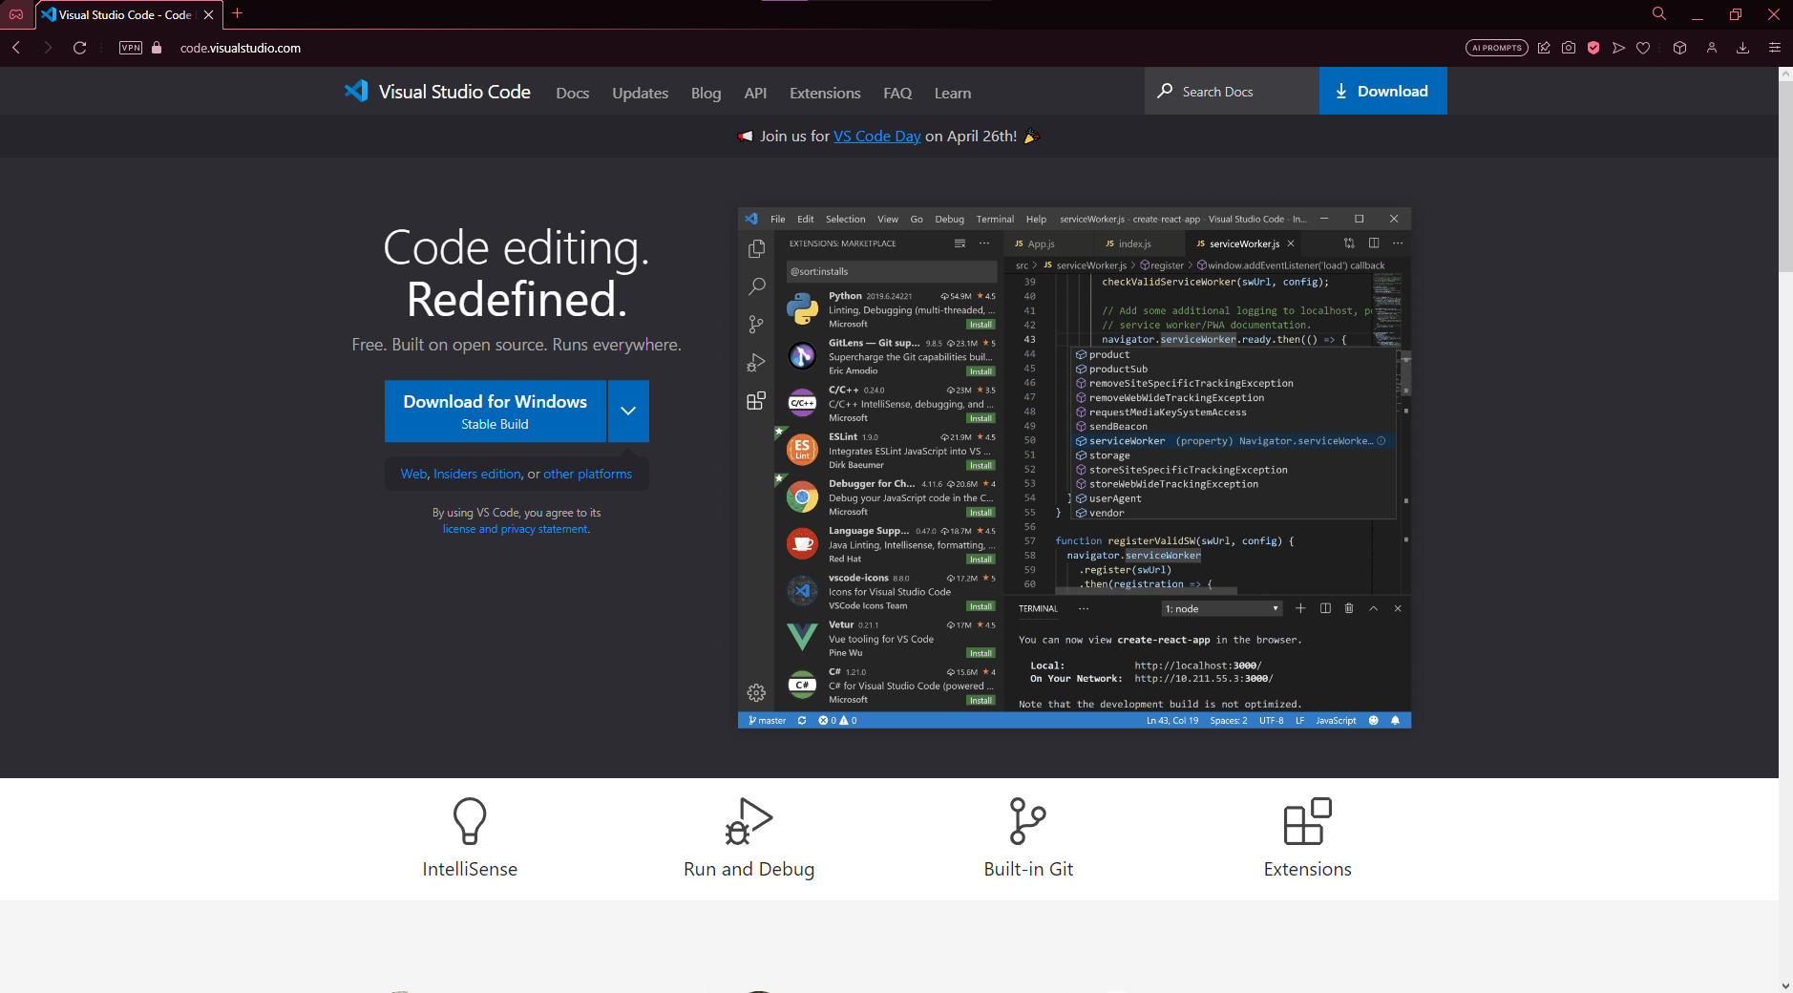
- Step Two: Install Python
  - via: https://www.python.org/downloads/
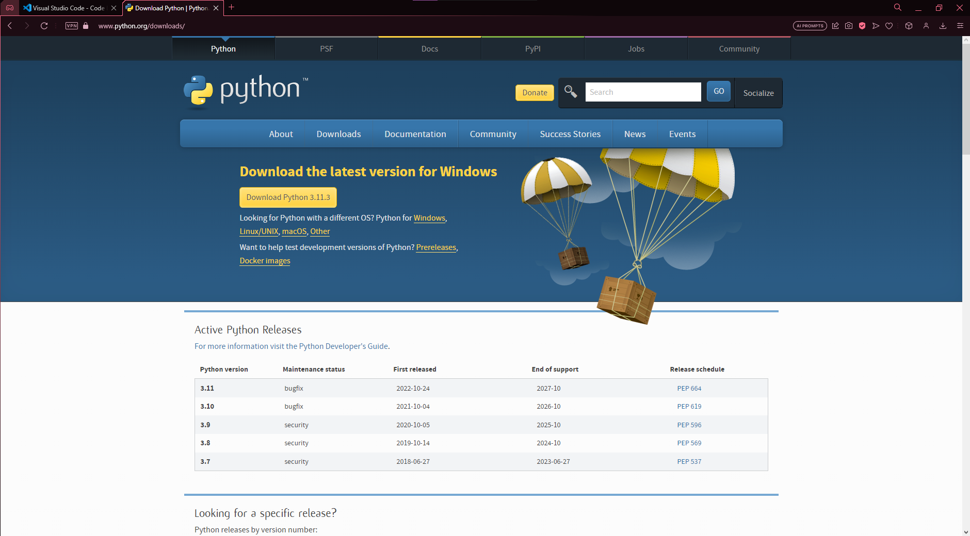
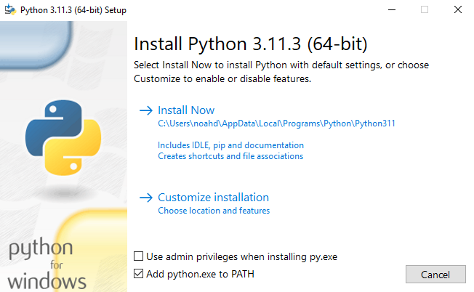
- Step Three: Open Command Prompt
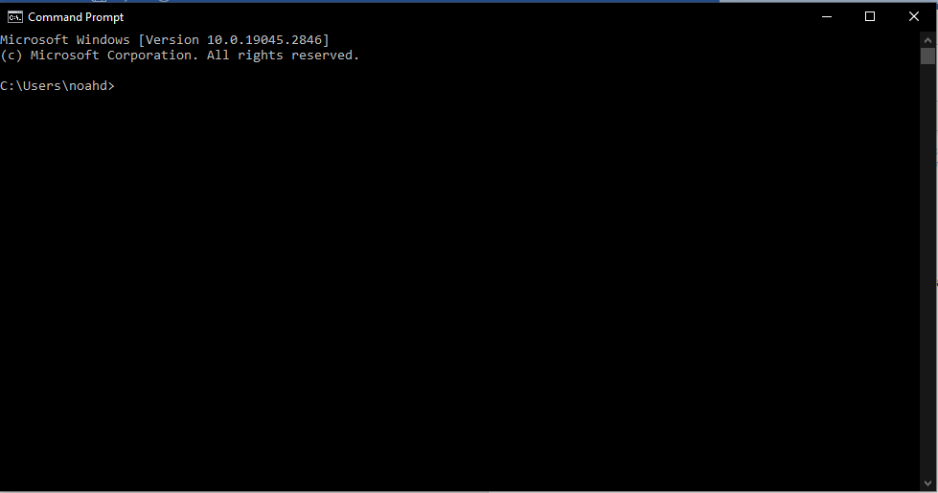

- Step Four: Install the PYGAME PIP
  - Type the following: pip install pygame
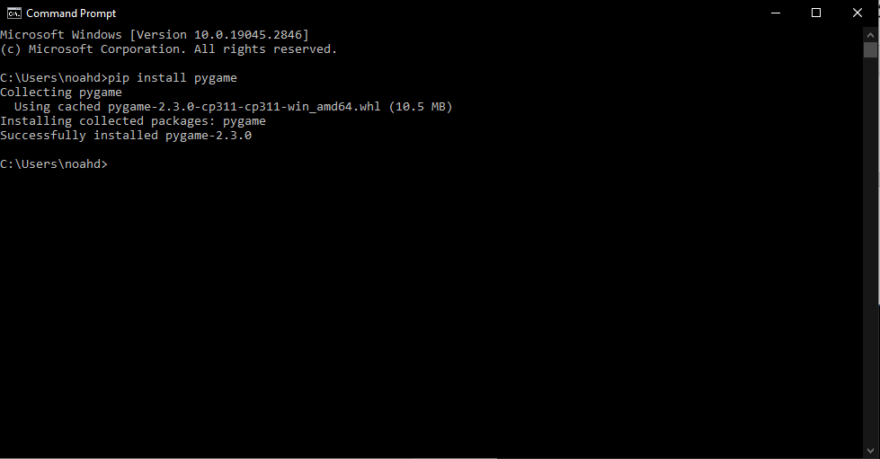
- Step Five: Open Visual Studio Code
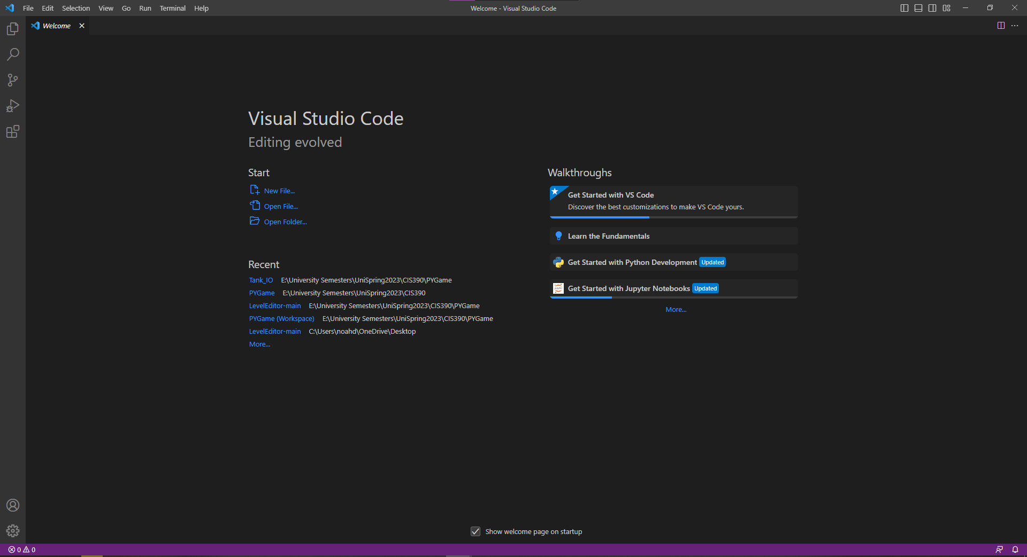

- Step Six: Install Python Extension
  - via: Visual Studio Code extensions tab
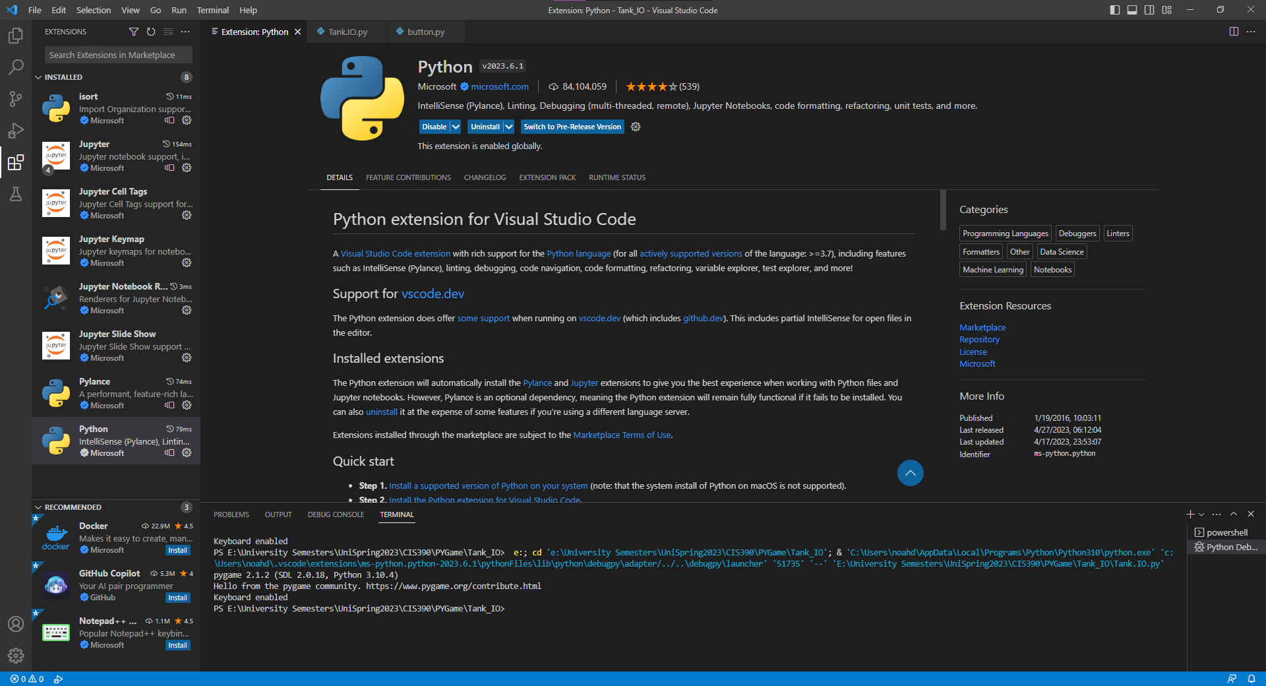
- Step Seven: Click "File"
- Step Eight: Click "Open Folder"
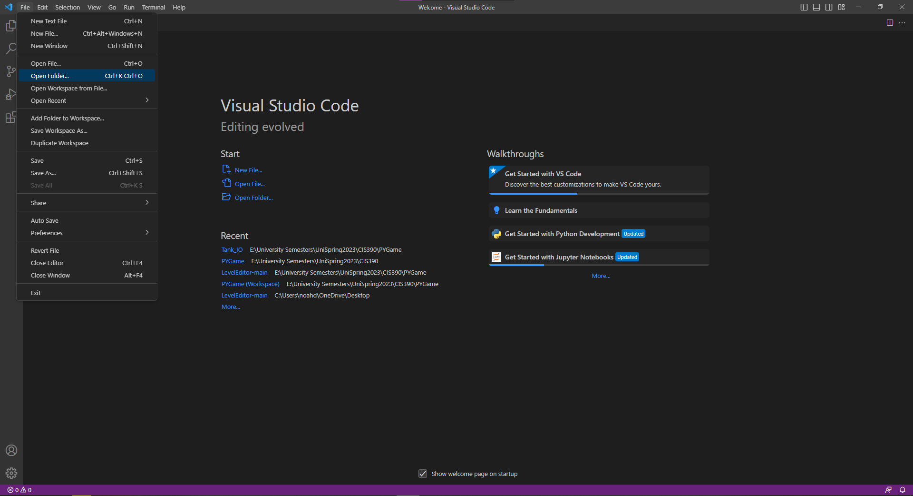

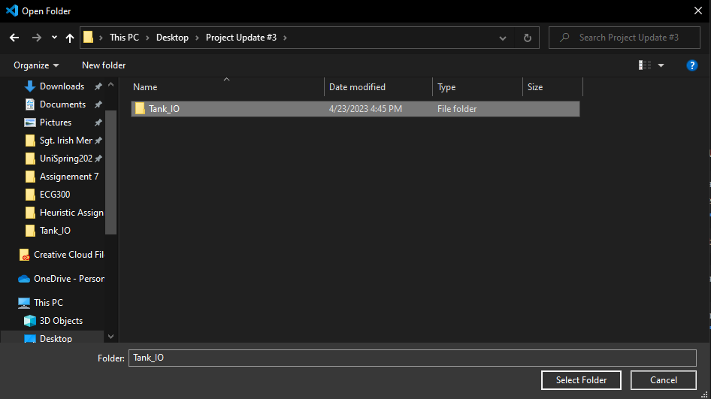
- Step Nine: Select the extracted folder named "Tank_IO”
  - Ensure "Tank.IO.py" is open on Visual Studio Code
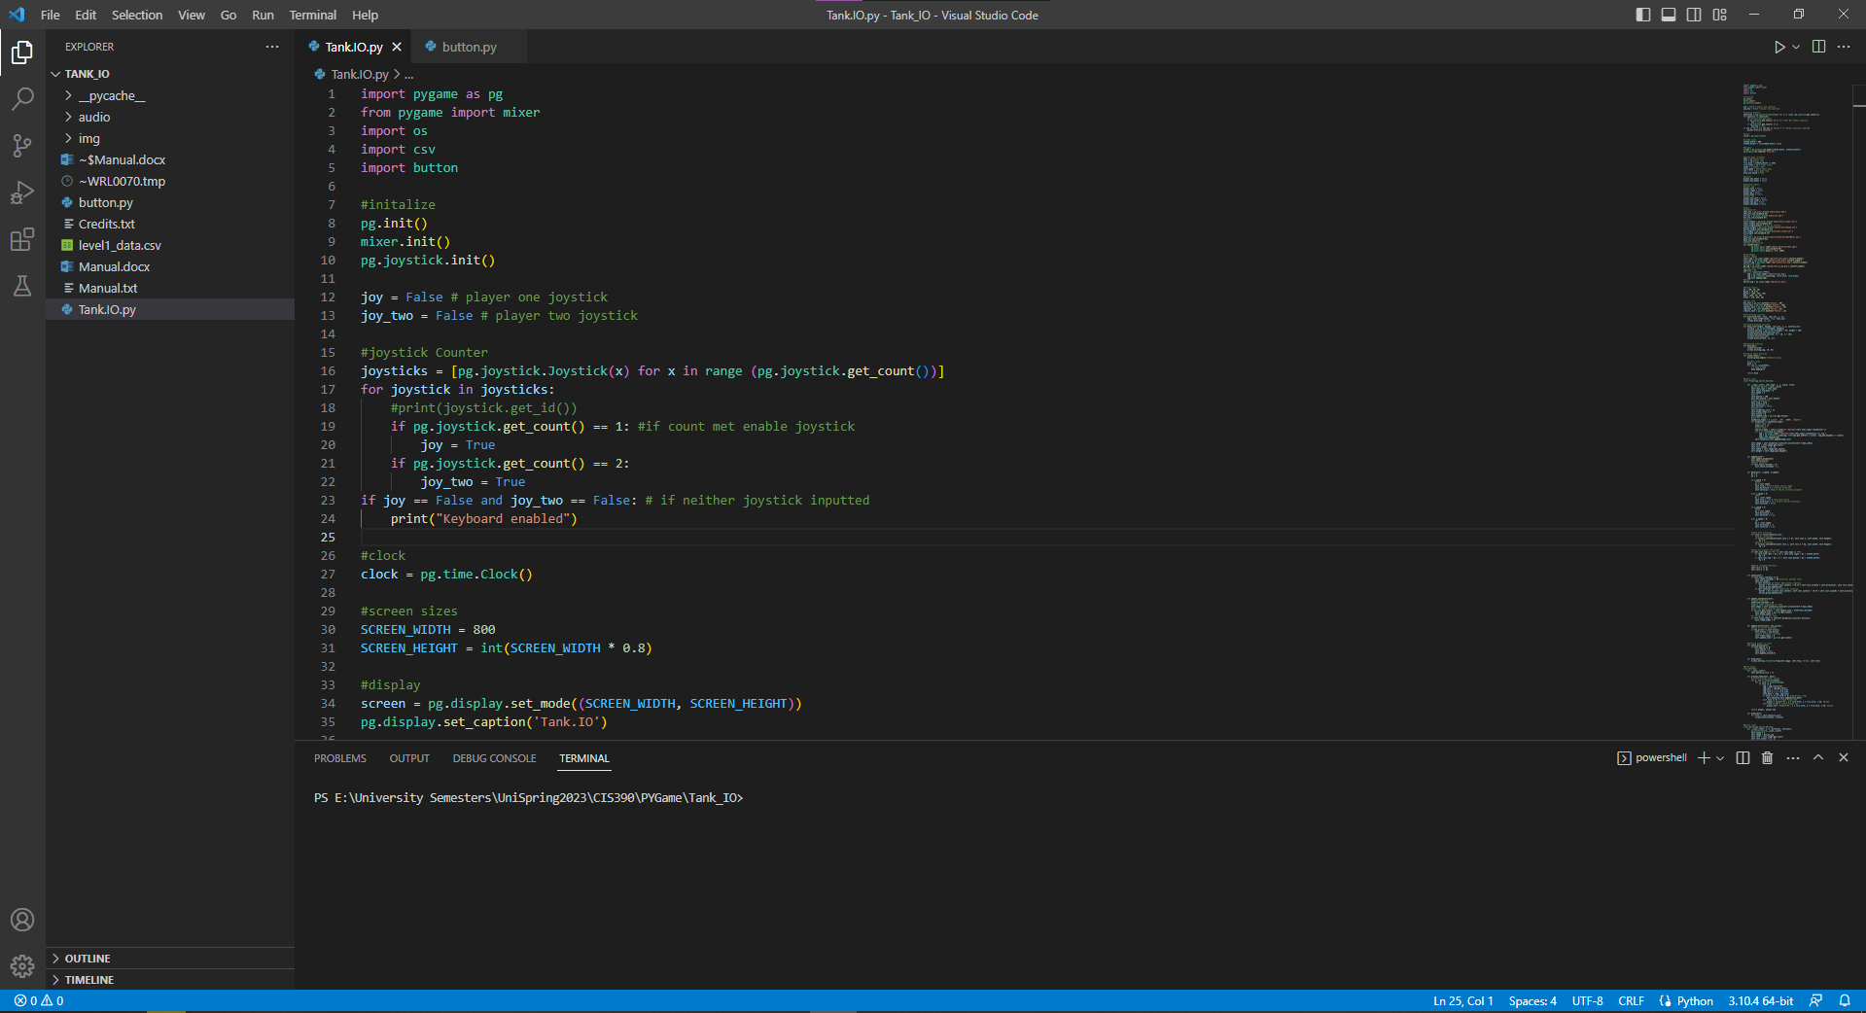

- Step Ten: Click on "Run" then "Start Debugging" or "Run without Debugging"
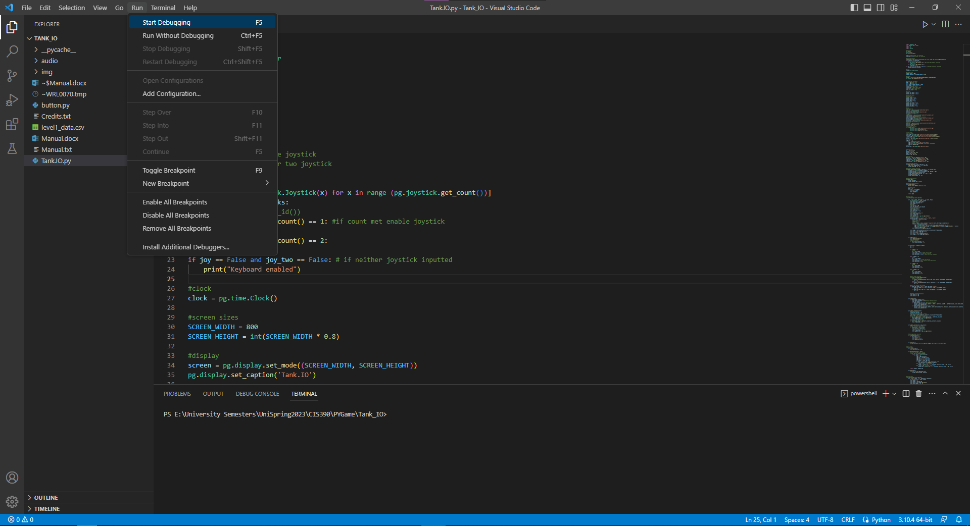
  - Click or search "Python File" if prompted
- Step Eleven: Main Menu should start!
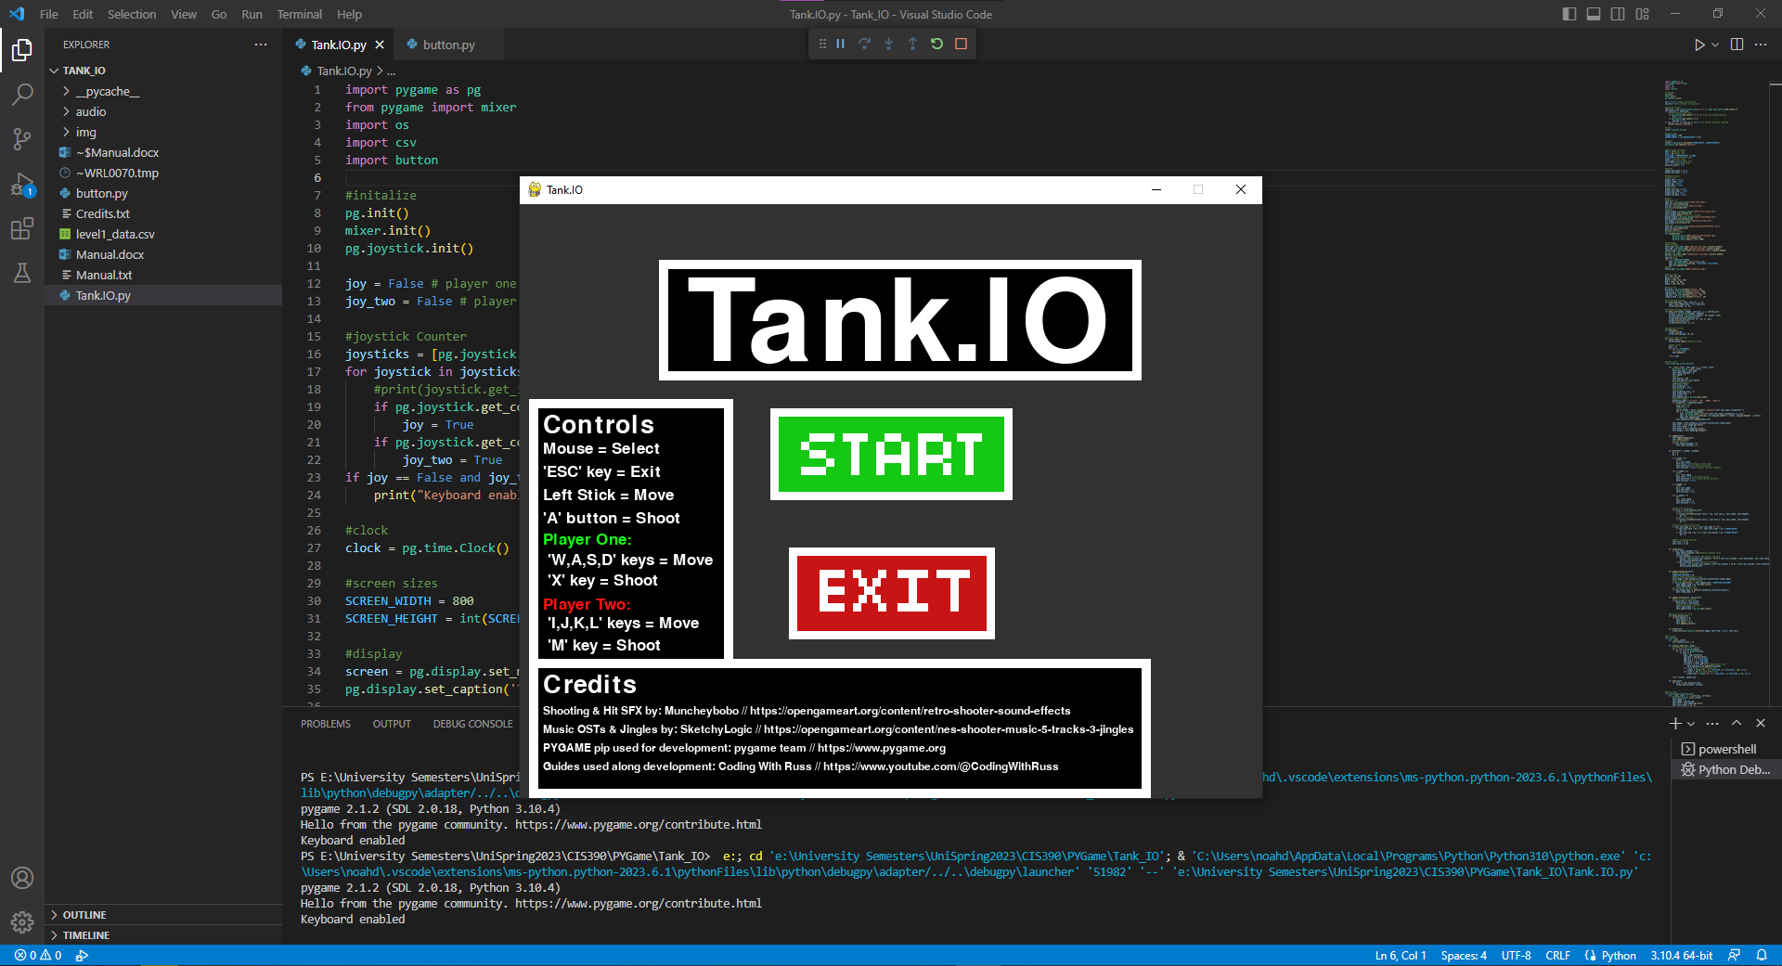

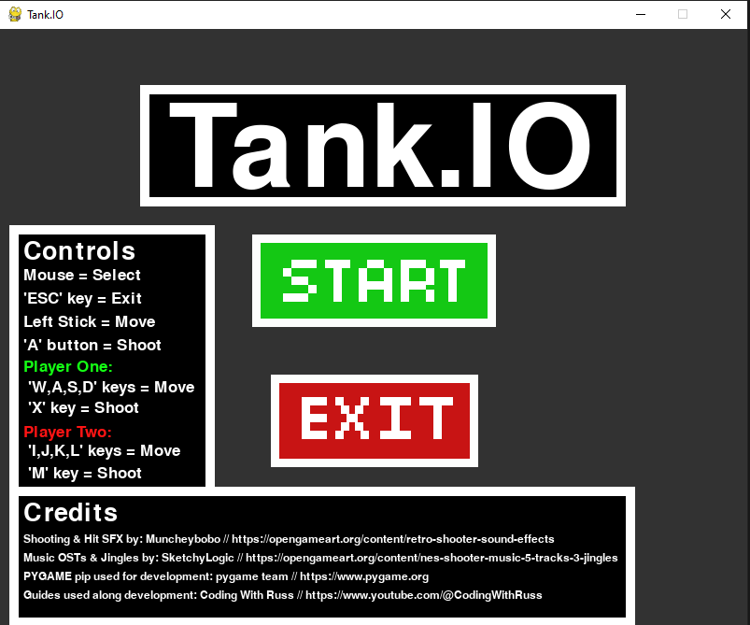
TANK.IO Game Menu
- How to start the game?
  - Click the 'Start' button to begin the game
- How to restart the game?
  - After a player wins, press the 'Restart' button
- Want to close the game?
  - Click the 'Exit' button to close the game
  - or press the 'ESC' key
- What are the controls?
  - Controls are located on side menu
  - Also located in the controls.txt file
- Want to use joysticks?
  - Use any USB compatible joystick e.g. Xbox controller, PlayStation controller, or Nintendo controller
  - If compatible game will say "Joystick Connected" in Terminal
================= Gameplay =================
- Hits to kill?
  - Each player requires 5 hits to win

